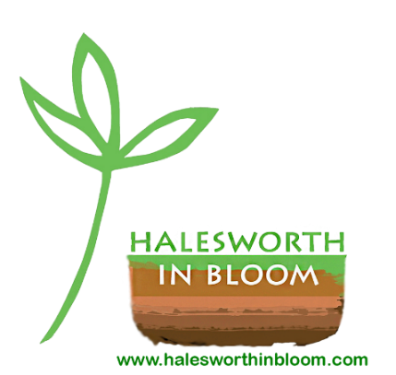
BECOME A “FRIEND” & SUPPORT HALESWORTH IN BLOOM
GOLD Awards in Anglia in Bloom
2014, 2015, 2016 & 2017
BEST SMALL TOWN IN 2015

WE AIM THROUGH HALESWORTH IN BLOOM
- To make people feel good by making our town and open spaces look good
- To involve everyone, young and old
- To show what plants can grow with less water
- To recycle rather than use up
- To grow and share flowers, herbs and food
- To help bees
- To create wildlife corridors and habitats
For more information, see our website: www.halesworthinbloom.com

YOUR OPPORTUNITY TO HELP & BECOME A “FRIEND”:
- Make a donation and contribute to the purchase of plants, compost and displays for public and communal areas of the town, as well as supporting the young, the handicapped and the elderly
- Provide a Raffle Prize item or service for raffles in aid of Halesworth in Bloom
- Give practical help with planting, weeding or watering

PLEASE COMPLETE THE FORM BELOW AND RETURN TO HALESWORTH LIBRARY (ask at Library desk for Halesworth in Bloom folder)
Any queries – Email: halesworthinbloom@mail.com
>>>>>>>>>>>>>>>>>>>>>>>>>>>>>>>>>>>>>>>>>>>>>>>>>>>>>>>>>>>>>>>>>>>>>>
PLEASE COMPLETE AND TICK AS APPROPRIATE
Name ……………………………………………………...........................
Email …………………………………………….....…... Tel: ………………….............
Address ...................................................................................................................
Postcode .........................

- I am making a donation of £......... to BECOME A FRIEND OF HALESWORTH IN BLOOM
- I will provide a Raffle Prize item or service for future raffles in aid of Halesworth in Bloom (please specify .................................................................)
- I would like to help with planting/weeding/watering

Please make cheques payable to “Halesworth in Bloom” (for regular contributions, a standing order form is available on request)

Signed ............................................................................ Date .............................
By providing Halesworth in Bloom with the above information you agree that Halesworth in Bloom shall hold relevant information solely to administer our membership and events. You can request that your information be removed at any time by emailing halesworthinbloom@mail.com.

